A numerical French obsession

Twenty times twenty

The strange suitability of the G20
Nov 5th 2011 | PARIS | from the print edition
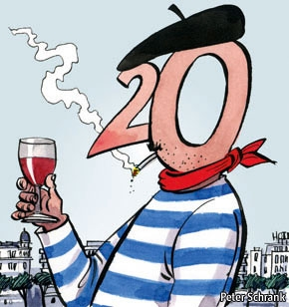
WORLD leaders and their motorcades will (1) even as the resort of Cannes closes down for the annual G20 summit. It is fitting that France is (2), not just because the euro is at the centre of the world’s current economic turmoil, nor yet because Nicolas Sarkozy (3) credit for reinventing the group after the 2008 financial crisis. It is also because the French have such a strange fetish for the number 20.
Teachers in France in all subjects, even sport, grade students out of 20, as does the school-leaving baccalauréat. The French language uses 20 as a (4) for counting between 70 and 100; hence 80 is quatre-vingts (“four-twenties”). Paris has 20 arrondissements, or boroughs. The capital’s annual running race is the 20 Kilomètres de Paris. There is a free newspaper called “20 minutes”. Even the main French television news is the Journal de 20 heures (the eight-o’clock news).
Jean-Pierre Bourguignon, director of the Institute of Higher Scientific Studies, says numbers like 12 and 60 are more (5), because they have more divisors. The vigesimal system (counting in base 20) is thought to originate from humans’ fingers and toes. It was used by the Mayans as well as by Celts and in other parts of Europe in the Middle Ages. In old French, 40 was deux-vins.
The French began to move to base ten in the 16th century; the metric system was first (6) in 1795. Yet traces of the vigesimal system linger, says Bernard Helffer, president of the Société Mathématique de France. The Fifteen-Twenty eye hospital in Paris still keeps its name. Founded in the 13th century, it was named for its 300 beds. The system of grading out of 20 in schools was introduced as recently as 1890. Whatever the origins of this curious French (7), it has nothing to do with another Gallic passion: it just happens that, when spoken, the word for twenty (vingt) sounds exactly like the word for wine (vin).

- A) Pull In
B) Pull Up
C) Pull Out
2. A) Host
B) Clipped
C) Welcoming
3. A) Deserves
B) Gains
C) Claims
4. A) Unit
B) Base
C) Block
5. A) Useful
B) Pointless
C) Interesting
6. A) Adopted
B) Enforced
C) Implied
7. A) Treat
B) Capital
C) Obsession

